NETWORK FUNDAMENTALS AND BUILDING NETWORKS

IP ROUTING AND IP PROTOCOLS

TASK1: Draw a simple network diagram showing three devices (like your phone, a friend's laptop, and a smart TV) connected through a router, and label the IP addresses for each device and the router's interfaces.
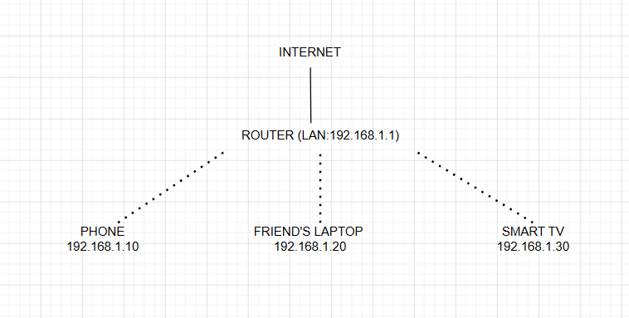

TASK2: Simulate manual IP routing by writing a step-by-step explanation of how a packet would travel from your laptop to a friend's computer in a different subnet, including which router(s) it passes through and how the routing decision is made.<br><br><em><strong>Hint:</strong> Use made-up IP addresses and show the routing table entries that would be checked at each hop.</em>

SCENARIO:
My laptop is on 192.168.1.10/24.
My friend's computer is on 192.168.2.20/24.
The router connects both networks.
STEPS:
- My laptop creates a packet for 192.168.2.20.
- The laptop checks its routing table.
- Since the destination is on a different subnet, the packet is sent to the default gateway (192.168.1.1).
- The router checks its routing table.
- The router finds that the 192.168.2.0/24 network is connected through its second interface.
- The router forwards the packet to the friend's computer.
- The friend's computer receives the packet and sends a reply back through the same router.
Destination Network | Subnet Mask | Next Hop | Interface
192.168.1.0 | 255.255.255.0 | Local | LAN1
192.168.2.0 | 255.255.255.0 | Local | LAN2
0.0.0.0 | 0.0.0.0 | ISP | WAN

TASK3: Create a routing table for a fictional Zomato-style delivery network with three branches in different cities, each on a different subnet. Specify the network address, subnet mask, next hop, and interface for each route.
Branch | Network Address | Subnet Mask | Next Hop | Interface
Delhi | 10.0.1.0 | 255.255.255.0 | Direct | LAN1
Mumbai | 10.0.2.0 | 255.255.255.0 | 192.168.100.2 | WAN
Indore | 10.0.3.0 | 255.255.255.0 | 192.168.100.3 | WAN

TASK4: Compare static routing and dynamic routing protocols (like RIP or OSPF) by listing 3 pros and 3 cons of each, using examples from real-world apps or services you use (e.g., how a food delivery app might benefit from dynamic routing).
Static Routing | Dynamic Routing
Pros
Easy to configure | Automatically updates routes
Uses less CPU and memory | Best for large networks
More secure because routes do not change automatically | Quickly finds a new route if a link fails
Cons
Must be updated manually | More complex to configure
Not suitable for large networks | Uses more CPU and memory
No automatic backup route | Can generate extra network traffic

EXAMPLE:
- Static Routing: Suitable for a small office network.
- Dynamic Routing (OSPF/RIP): Better for a food delivery company like Zomato, where many branches need automatic route updates.

TASK5: Use ChatGPT or another AI tool to generate a sample configuration for setting up OSPF routing between two routers, then explain in your own words what each configuration line does.<br><br><em><strong>Hint:</strong> Paste the AI-generated config and annotate each part with a short description.</em>

SAMPLE CONFIGRATION:
Router(config)# router ospf 1
Router(config-router)# network 192.168.1.0 0.0.0.255 area 0
Router(config-router)# network 192.168.2.0 0.0.0.255 area 0
Configuration Line | Description
router ospf 1 | Starts the OSPF routing process.
network 192.168.1.0 0.0.0.255 area 0 | Adds the 192.168.1.0 network to OSPF Area 0.
network 192.168.2.0 0.0.0.255 area 0 | Adds the 192.168.2.0 network to OSPF Area 0.

